NAME: Alyssa Hacker PRODUCTION: Hacker Educational PAGE: 1

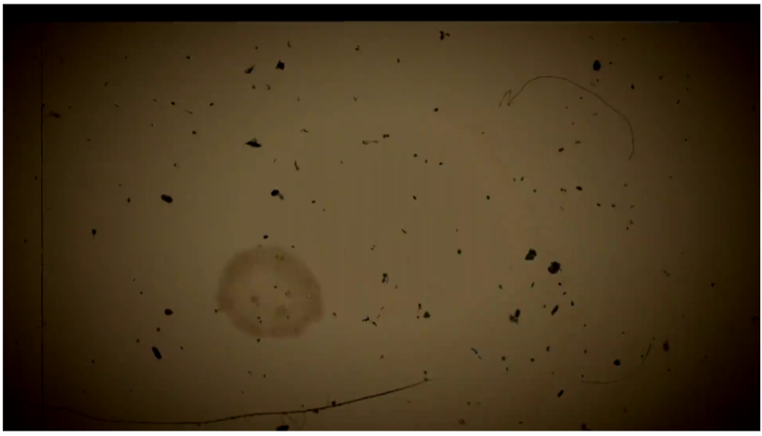
SOUND: Narrator speaking and music playing softly
ASSETS: video and images
ANIM: Cut to typewriter

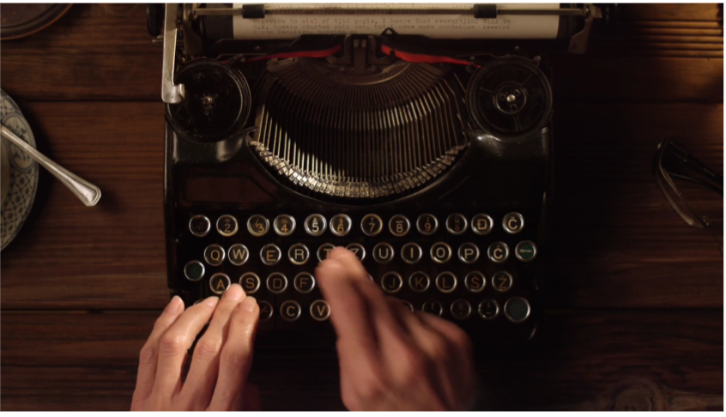
SOUND: Narrator speaking and music playing softly
ASSETS: video and images
ANIM: transition to two animated computers shaking hands

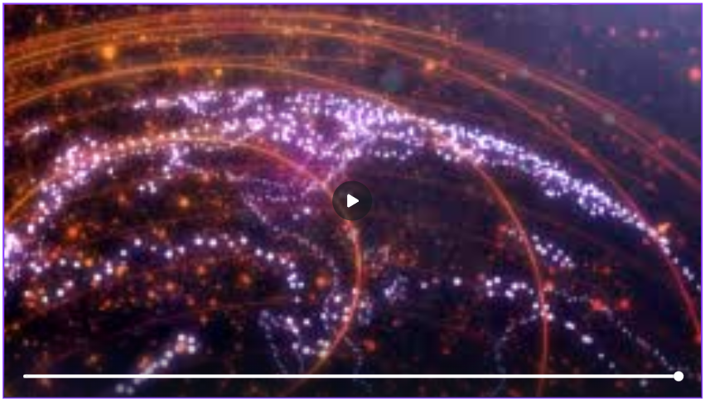
SOUND: Narrator speaking and music playing softly
ASSETS: video and images
ANIM: Transition to old timey video style

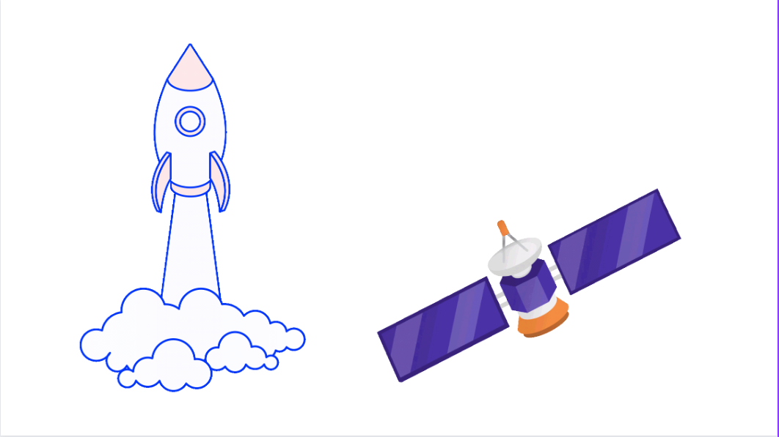
SOUND: Narrator speaking and music playing softly
ASSETS: video and images
ANIM: Transition to two computers shaking hands


SOUND: Narrator speaking and music playing softly
ASSETS: video and images
ANIM: Cut to @ symbol dancing around emails

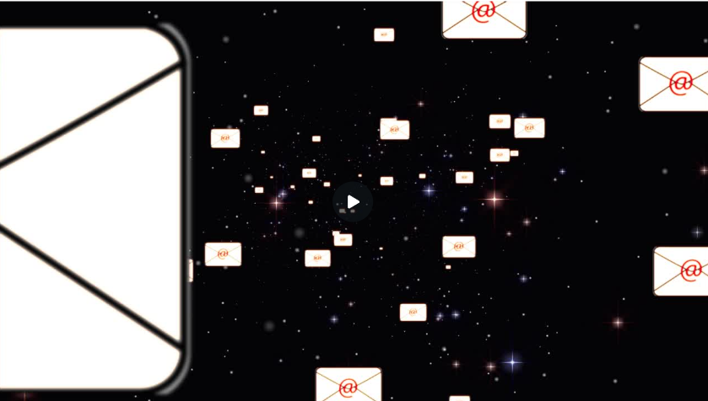
SOUND: Narrator speaking and music playing softly
ASSETS: video and images
ANIM: Cut to confused person becoming happy

NAME: Alyssa Hacker PRODUCTION: Hacker Educational PAGE: 2


SOUND: Narrator speaking and music playing softly
ASSETS: video and images
ANIM: Cut to time line

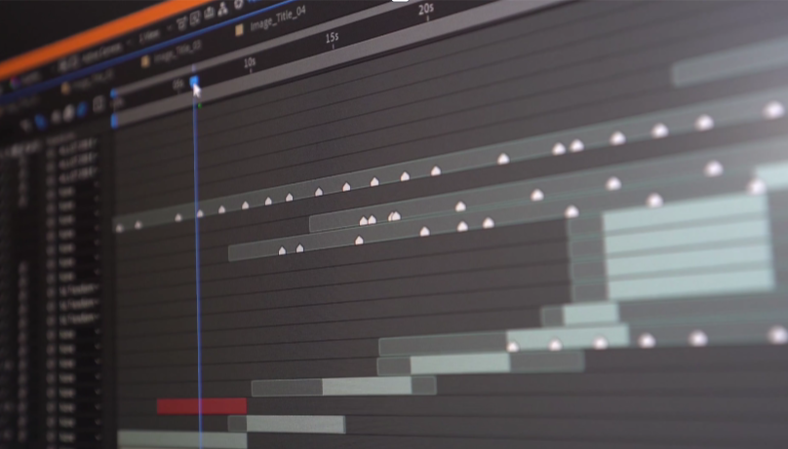
SOUND: Narrator speaking and music playing softly
ASSETS: video and images
ANIM:Cut to earth from space

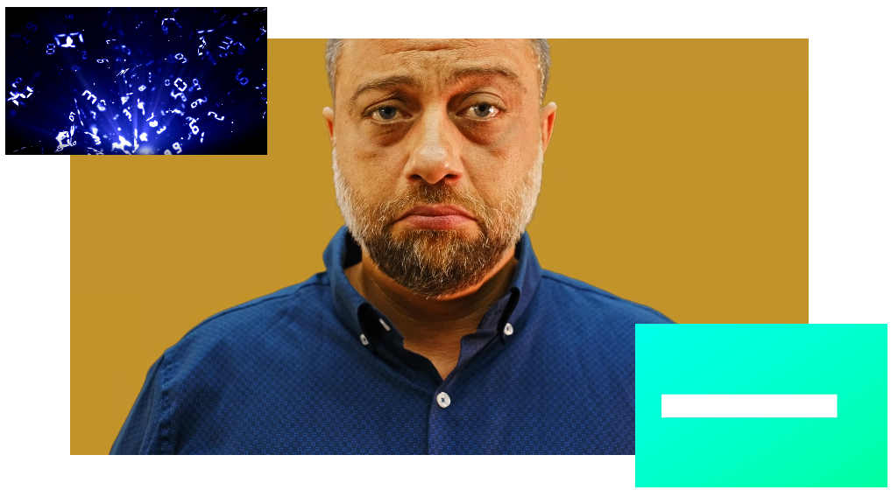
SOUND: Narrator Speaking and music softly playing
ASSETS: video and images
ANIM: Cut to Computer with code flying around


SOUND: Narrator Speaking and music softly playing
ASSETS: videos and images
ANIM: cut to thanks

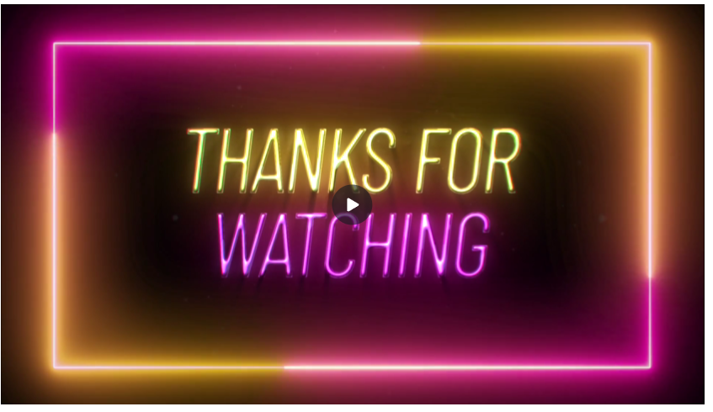
SOUND: Narrator Speaking and music softly playing
ASSETS: videos and images
ANIM: Thank you

SOUND:
ASSETS:
ANIM:

